Sunshine Neighborhood Watch – CERT Team (Est. 2008)
SCCE - Harlingen’s premier NW & CERT Team.

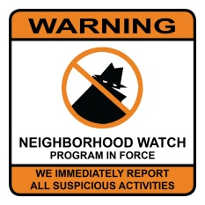
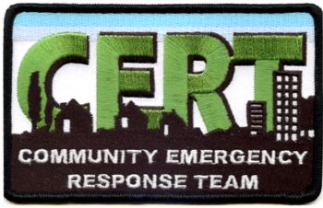
Lights On -- Lock Up and Look Out for each other!

Meeting Agenda – 17 June 2019
Lenore J. Combs, Coordinator 956 245 1276 LJCombs44@gmail.com
Sgt. Michael Brooks, NW HPD District Representative

Dear NW-CERT Volunteers and Friends,
Welcome, Pledge of Allegiance, Moment of Silence – thoughts for special intentions
National Police Memorial Week
Coffee n Cookies
Introduction of guests or new residents

This is an open meeting and we welcome everyone. The agenda is a planning guide.

New Business
Thanks to all who helped patrol for the Estate Sale

National Night Out: our chance to take a bite out of crime.
We – NW and CERT will have a table at NNO this 6th of August. Mark your calendars
Please come out and meet our neighboring Neighborhood Watch volunteers – great time to share experiences and meet our Police Department.

BTW – let’s hear it for the new Assistant Chief of Police -- Miryam Anderson
It was her hard work with the HPD District Representatives that set our course for NW. We wish her many safe and great years ahead.

July Patrol Schedule. Please notify Lenore for any changes or concerns….
Summer Patrols (locking up the buildings)

McGruffmobile – please notify Lenore if there are any concerns with the golf cart or its equipment. Sometime notes are not the most efficient system of communication. Please treat McGruff as thought it was your own golf cart. On a good day, it is rode hard and put up wet.

New Gates on the Resaca off Missouri

Old Business:
Generator - Wade has the key and will check it monthly during the summer.

Buzzers and solar lights…..
Have not seen many of these in place since our last discussion – some areas are still very dark.

Block Captains – who’s where?
Montana Nebraska Missouri Michigan Indiana Wisconsin Iowa Minnesota Kansas

Vendors – must report to Office for Orange Cards. It is each resident’s responsibility to make sure vendors report in. Please call Lenore and I can also get you these ID cards.

IR Sensaphone – Storage Lot

Disaster Preparedness: Hurricane Season - June July August September October November
Map of SEPO who’s here or not -- evacuation plans (SCCE & HPD HFD EMS Combes PD)
Plat of community to EMS & Comm Center ----- Hand-outs c/o CERT

