Sunshine Neighborhood Watch – CERT Team (Est. 2008)
SCCE - Harlingen’s premier NW & CERT Team.

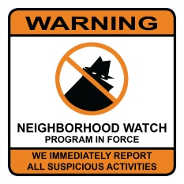
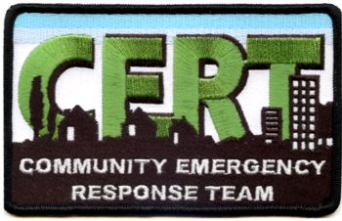
Lights On -- Lock Up and Look Out for each other!

NATIONAL NGHT OUT TUESDAY -- 6 AUGUST 6PM – 9PM

Lenore J. Combs, Coordinator 956 245 1276 LJCombs44@gmail.com
Sgt. Michael Brooks, NW HPD District Representative

Dear NW-CERT Volunteers and Friends,

The Harlingen Police Department heads up this annual event. We, the Neighborhood Watch groups have a special spot under the trees in Lon C. Hill Park on Fair Park Blvd, just down from the Police Department.

Tuesday 6 August 2019 6pm – 9pm

Many partners are represented – lots of sharing of information and especially it’s our night to show the Bad Guys we are taking a “bite out of crime”.

This event has been held since 1984 and is sponsored by the National Association of Town Watch in the U.S. and Canada. It began simply as neighbors turning on their porch lights and sitting in front of their homes putting the Bad Guys on notice: we are taking back our neighborhood. It promotes community partnerships and neighborhood comradery to make our neighborhoods safer and more caring places to live. NNO enhances the relationship between neighbors and law enforcement while bringing back a true sense of community – and under positive circumstances.

NNO is a community-police awareness raising event held the first Tuesday in August. It is a great opportunity meant to bring awareness about police programs to our community such as anti-crime efforts, gangs, drug prevention and many more. Harlingen goes a step further and has a big support function locally. Please come out and join us for this worthy presentation. Fantastic food (all free), many activities, exhibits, demonstrations, Sounding of the Sirens – Police, Fire and EMS, etc., displays on all emergency equipment, lots of educational stuff and great community support. The CERT Team will have a roving First Aid Station.

